Guidelines for Funding of Post-Secondary/Graduate Studies

Lethbridge College continues to support the professional development of college staff as essential to its people development strategy. From time to time, an employee may request financial support from their supervisor for an accredited program of study. Any professional development for admin/excluded and/or AUPE employees must be funded from the departmental budget. This can be partially or fully funded if it is determined by the CLC member that the request is mutually beneficial to the college and the employee. Should the request be approved, the following steps should be taken to formalize the request.

Step | Action
Has an education agreement been signed? | Forward a signed copy of the educational agreement to Human Resources.  https://lethbridgecollege.ca/document-centre/forms/human-resource-services/educational-agreement-template-long-version - long version can include travel, books, and tuition (full or partial).  https://lethbridgecollege.ca/document-centre/forms/human-resource-services/educational-agreement-template-short-version - short version is typically for tuition only.
Is the credential a requirement of the job or for professional development? | Click the appropriate box on the educational agreement to indicate if this credential is a taxable benefit
Is further education part of the employee’s development plan | Enter credential information in development plan in SumTotal (see below for instructions)

Log into SumTotal

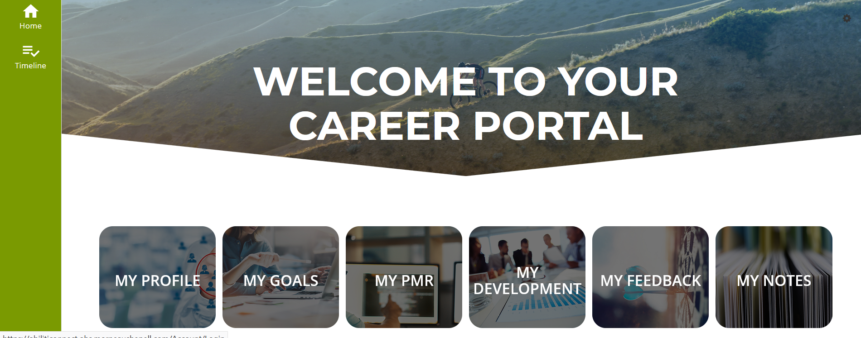

Step 1: Click My Development
Step 2: You can create a Development Objective by clicking Add Development Objective. Examples of development objectives include “Complete Graduate Studies” or “Develop Communication Skills”. Your Development Tasks can be tied to Development Objectives.
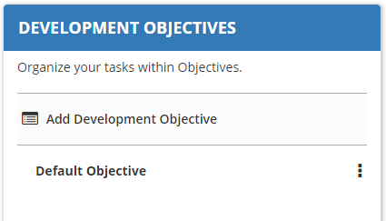
Step 3: To be more specific, you can create a Development Task by clicking Add Development Task. Click External Task.
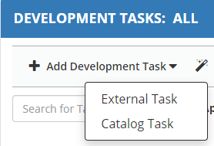

Step4: In the Add External Task menu, enter the Status, Progress, Task Name, Objective, Aligned Competency (if applicable) and Description. This could be a more detail plan of how many courses per semester you will take, etc.
Step 5: Once your Development Plan is complete, click to submit to your supervisor.

